Integrating Discovery Education into Your Curriculum
Workshop presented June 26, 2014

What is Discovery Eduation?
Discovery Education (DE) is a robust online tool that provides you with an incredible library of digital content. You not only have videos and images, you will find educational games, audio files, images and clip art, an interactive atlas, skill building activities, math explanations and much more.

Discovery Education will help you use media as a tool do differentiate instruction and it is a tool that is available to all students when they have access to a computer (at school or at home).

What we will cover?
The goal today is to begin to learn some of the many features available in Discovery Education. These features include:
- Logging into Discovery Education
- Search features
- Types of digital media
- Storing and downloading
- Lesson planning

By the end of the workshop you should be able to:
- Navigate and effectively search for appropriate digital content from DE
- Understand the various types of digital content available through DE Streaming
- Download and store digital content for lesson planning
- Integrate digital content appropriately into one lesson plan
- Create at least one new lesson plan that incorporates digital media and content effectively as well as key strategies to increase student engagement

You may also be able to:
- Set up a class
- Set up a board

The quickest way to access DE is to go to either the Student or Staff page on the district website and look for the Discovery Education logo. Click on the logo and you will see this screen.

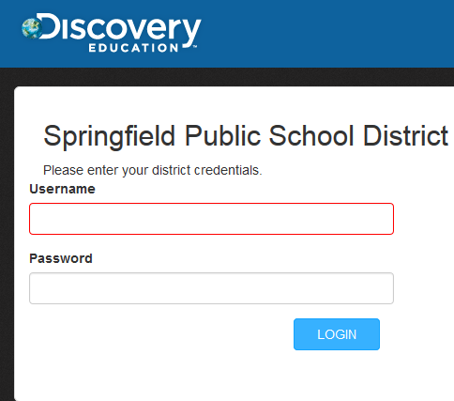

Fill in your user name (just as you would log-in to your computer at school) and your password.
This screen will appear.

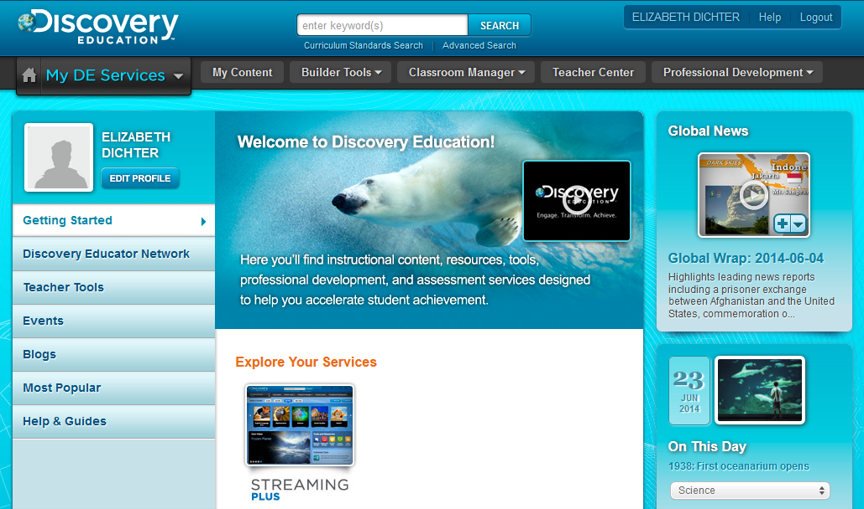

We will review some of the tools that you may access from this page.

Let’s begin with the Search Tools. There are a variety of ways you may search for material. They include:
- Keyword search
- Advanced search
- Refine the search by specifying subject, grade level, media type, language, video detail, related materials, subject and/or source. Many of these items may be expanded to provide additional filters.

We will first create a new folder for you to store information you find on DE. Today you will create a folder on your desktop. You may move it to a different location at the end of the workshop. Go to your desktop and right click on the desktop.

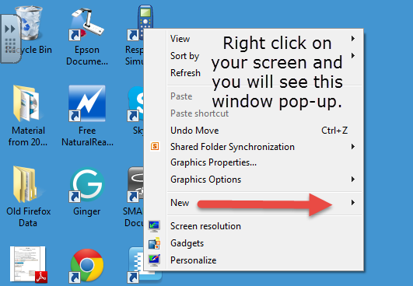

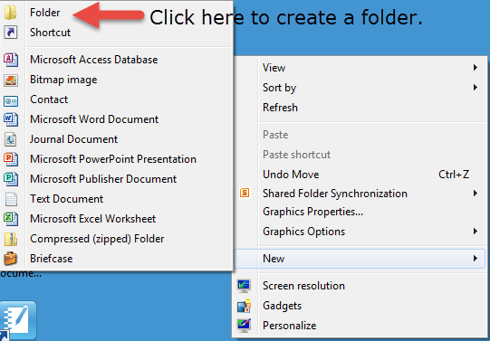

Name your folder Discovery Education (or whatever will work for you). This may be the location you will save your work today.

You may also want to save within DE. To do this you will need to go to My Content, the tab right next to the Home Tab (which also says My DE Services in blue). You may also create folders in this tab. Begin by creating one folder. Click on the Add Folder (blue folder next to the orange folder on the upper right hand side). Make sure you name your folder. You can upload files from your computer to this section. More on that later.

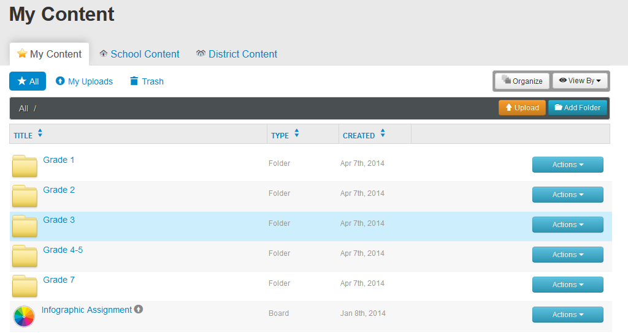

Let’s begin by searching for a video using Curriculum Standards.

At the top of your screen you will see the image below. The white box that says “enter keyword(s)” is one to do a search. This time please click on the Curriculum Standards Search.

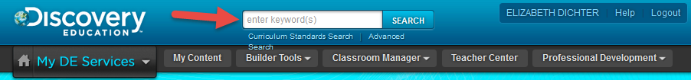

The new window below will open:
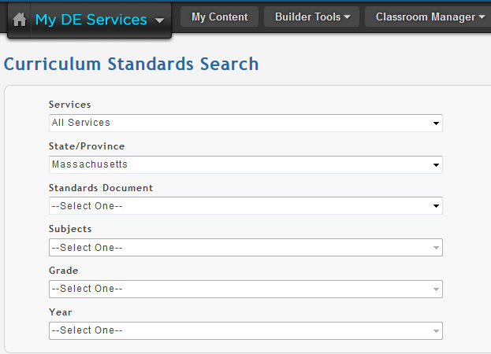

Since we all teach different grade levels and subjects you must begin to make decisions. Below is a short list of what each box provides.

Services: There is only one option to choose which is DE Streaming.

Standards Document: You have four choices here. You may select
- Common Core Standards
- Concepts and Skills
- Curriculum Framework (Common Core)
- Curriculum Frameworks.
As far as I can tell the Common Core Standards and the Curriculum Framework (Common Core) take you to the same options.

Subjects: If you select 1 or 3 you will see ELA and Math. If you select 2 you will see Social Studies. If you select 4 you will see a wide range of subjects.

Grade: Select the grade (Kindergarten through Grade 12 are listed.

Year: When you select the grade the last option will automatically be filled in.

In the image below you will see that I selected Curriculum Standards, Grade 5, and then Integration of Knowledge and Ideas. I can now select any one of the four listed.

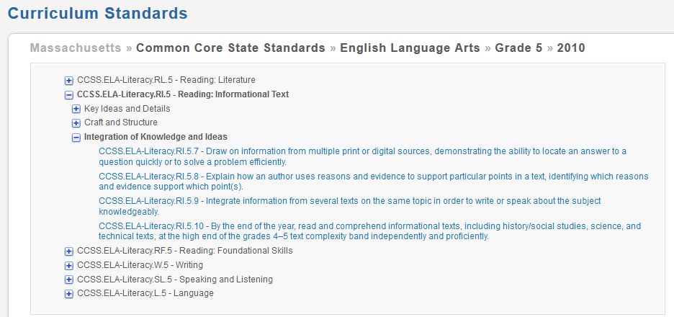

The image below shows the options that were provided for this search.

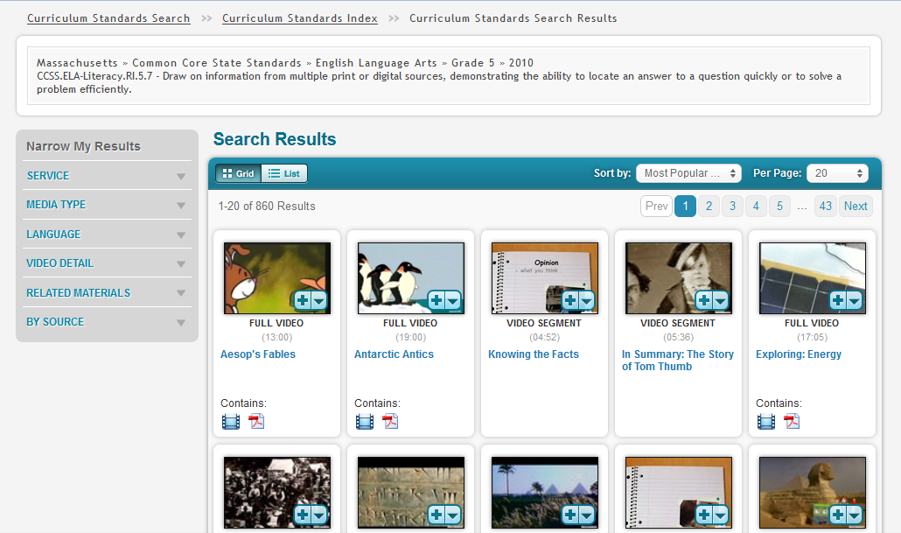

Our goal today is to find short videos (2-3 minutes). You will notice in the screen shot above that links are in blue, and that some videos also include a pdf file. The pdf file is usually a Teacher’s Guide.

You will also see the for each result.The + sign allows you to add the video to your Quick List. The downward arrow provides additional options. See the image below:
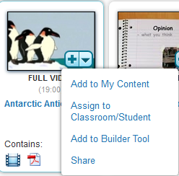
You may place this in My Content. You may assign it to your classroom/students. You may add to the builder tool or you may share with others.
If I click on the video the following screen appears:
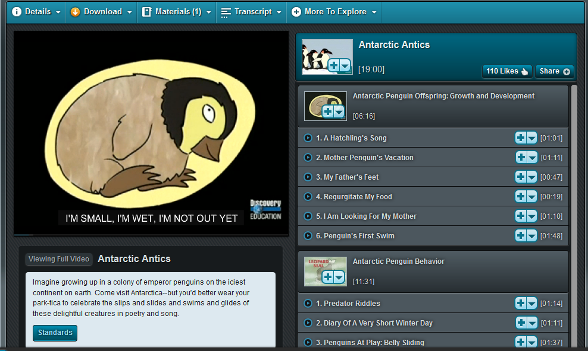
Although this video is 19 minutes in length, you have the choice of watching the entire video or you may choose to select a specific portion. If you were teaching about predators the first segment I the Antarctic Penguin Behavior will provide a shorter segment for students to learn about the three primary predators of Antarctic penguins.

One of the first things we need to do is find the settings button for the video. The red arrow points to the wheel. Please click the wheel.
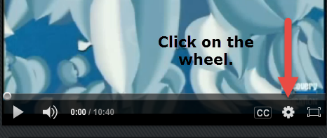

The following screen should appear. Make sure your settings look like mine below and click on Save.
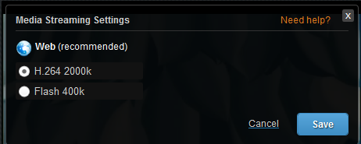

You will notice a number of options at the top of the video.

The details tab provides additional information. Below is the detail tab for this video.
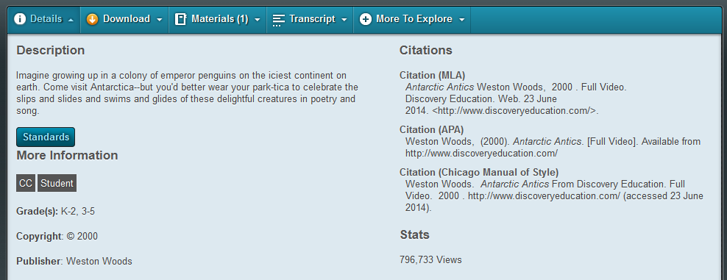

The next tab is the download button. Although the district does store all Discovery Education videos on a server, it is suggested that you save videos locally. This allows them to stream more quickly (and if we are having Internet issues you may still view the video).

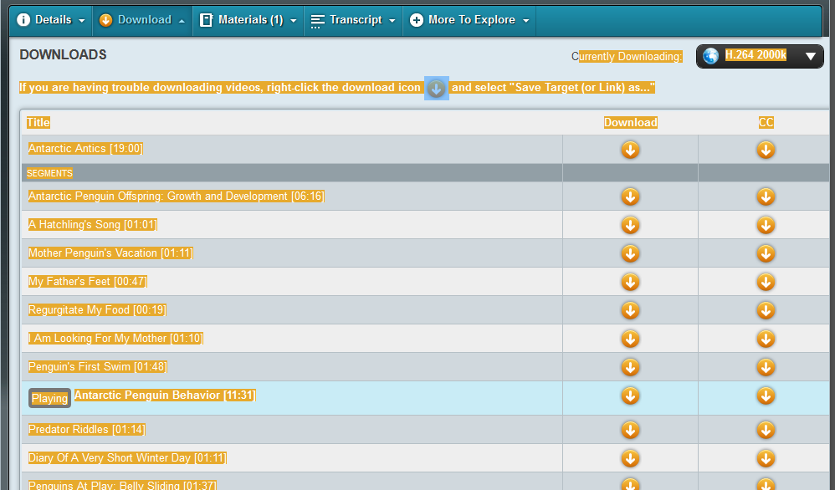
Please note that you may download individual segments or the entire video.

Next to the Download tab is the Materials Tab. If there is a Teacher’s Guide you may use this tab to download it.

The next tab is the Transcription Tab. This provides you with a detailed transcription that also provides the specific timing for the video (at least, it has in all the ones I have reviewed).

Do you need to find additional resources that may relate to your topic? Check out the More to Explore tab and see what comes up.

We did this search using the keyword search area to begin. You may drill down a bit more by using the Narrow My Results, which is to the left of the page. This is a longer section so it is broken up below.

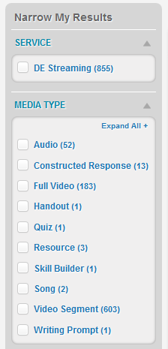
Search Filters – One Way to Quickly Drill Down
We only have access to the DE streaming but there are many media types to choose from. Click on the DE streaming and choose the specific media type (or types) by clicking the categories that you are looking for.
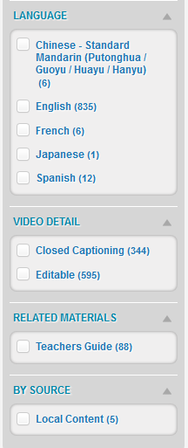
The majority of resources are only available in English, but you may choose close captioning for the videos. You will notice that only about 10% of the videos come with Teachers Guides. It is also possible for you to create content and upload it to the site so others may find it. To my knowledge these items are not vetted by DE.
If we were to return to the top of the page again under the keyword search you will also find the Advanced Search. If you click on this the following screen comes up.
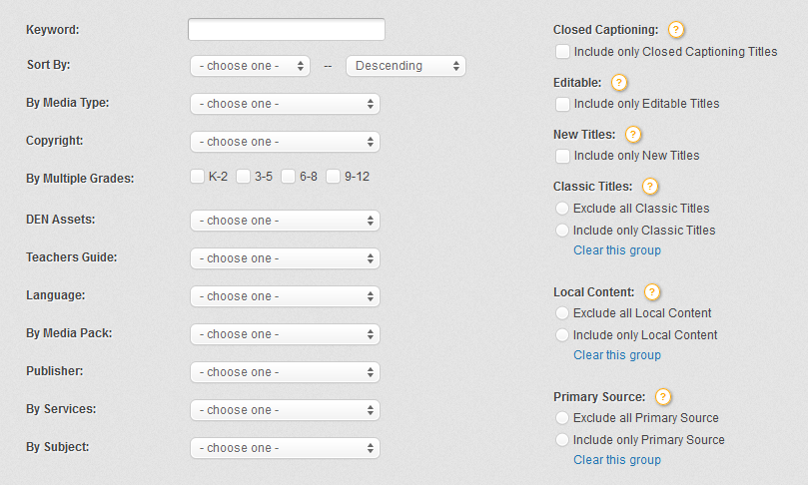
Again, you may select each item and then choose what you are looking for. This may help you find specific items more quickly.

Key Word Search
You may simply type in a word or phrase for key word search but when you click on the box menu drops down.
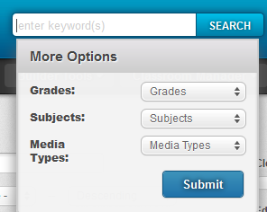
Spelling counts!
Are you searching for a phrase? Use quotations marks around it.
Check out the dropdown menu next to Grades, Subject and Media Types to quickly find what you are looking for.

The Builder Tools provides a variety of resources. If you click on the Teacher Center tab you will see:
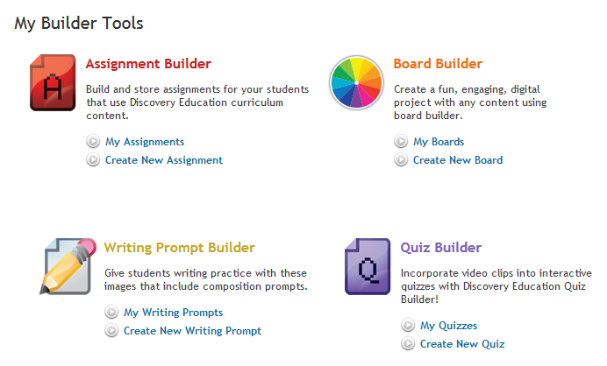

In the Assignment Builder, Writing Prompt Builder, and Quiz Builder there are four tabs: My Assignments, School Assignments, District Assignments and DE Assignments. You will find some samples of assignments only in the DE Assignments.
The same tabs are also located in the Writing Prompt Builder and the Quiz Builder and there are samples in the DE Assignments.

The Board Builder provides several possible templates. It does provide one sample board.
Each section provides assistance to help you create the activity.

The Classroom Manager section is currently populated with the 2013-2014 students. This will be updated by OITA at some point.
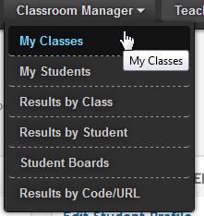

The Teacher Center provides many additional resources:
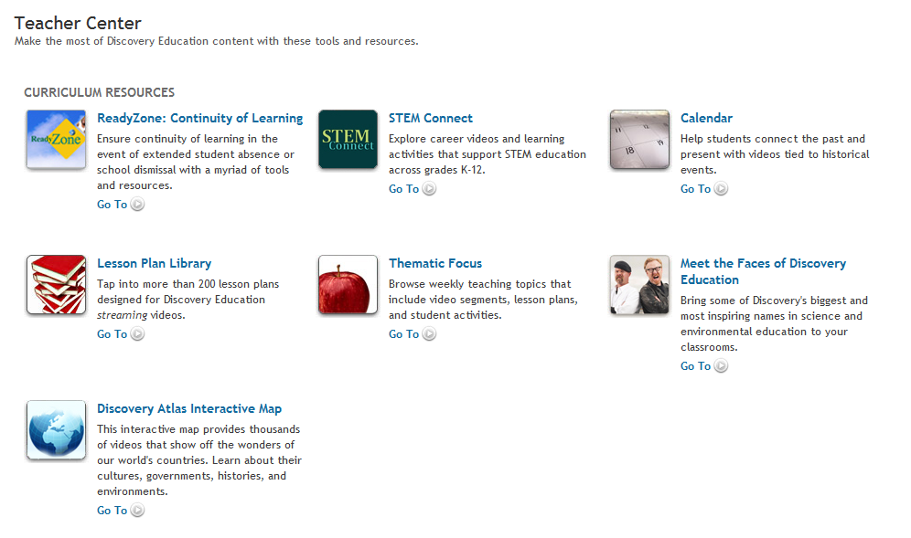
They are briefly defined above. If you have time today select one or two of the items and see what you find that you might use in class.

DE also provides online tools for Professional Development, including many videos that will walk you through how to use the tools. See the screen shot below.
